

**VIDEO GAME DISTRIBUTION SERVICE**

**Software Requirement Specification**

– Hanoi, August 2022 –

Record of changeS

|  |  |  |  |
| --- | --- | --- | --- |
| Date | A* M, D | In charge | Change Description |
| 13/Apr | A | KienNT | Thêm mô tả chức năng Setting Details (II.1.a) |
|  |  |  |  |
|  |  |  |  |
|  |  |  |  |
|  |  |  |  |
|  |  |  |  |
|  |  |  |  |
|  |  |  |  |
|  |  |  |  |
|  |  |  |  |
|  |  |  |  |
|  |  |  |  |

*A - Added M - Modified D - Deleted

# Table of Contents

I. Overview 4

1. Introduction 4

2. System Functions 5

3. Entity Relationship Diagram 6

II. Functional Requirements 7

1. <<Feature Name 1>> 7

a. <<Function Name 1>> 7

b. <<Function Name 2>> 7

2. <<Feature Name 2>> 7

# I. Overview

## 1. Introduction

Video Game Distribution Service is a web application that allows people that love video games to upload and sell their own games online. Meanwhile, anyone visiting the website can register for a free account to buy whatever games they want.

Game with good quality but at affordable prices for the community remains the top priority for our website. Our goal is to bring the gaming community the best experience when visiting our website.

* Guest: unregistered users.
* User: registered users who can purchase items online and interact with them(rate, comment,…)
* Publisher: registered users who sell their games to the customers.
* Admin: the system administrator.

**The interaction between the system and external entities is described as the following diagram:**

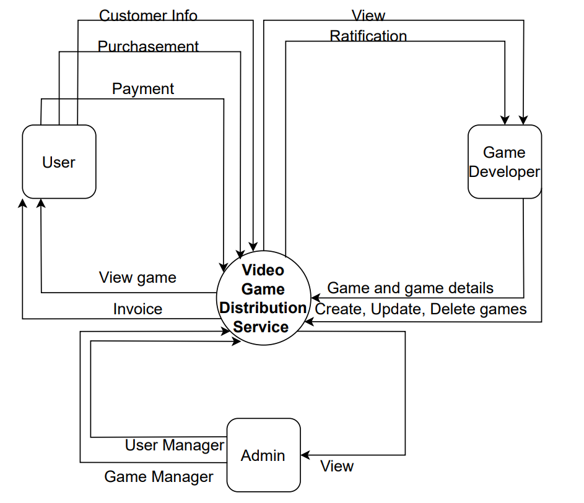

**Figure 1.1: Interaction between the system and entities**

## 2. System Functions

#### a. Screen Flow

User Screen Flow:

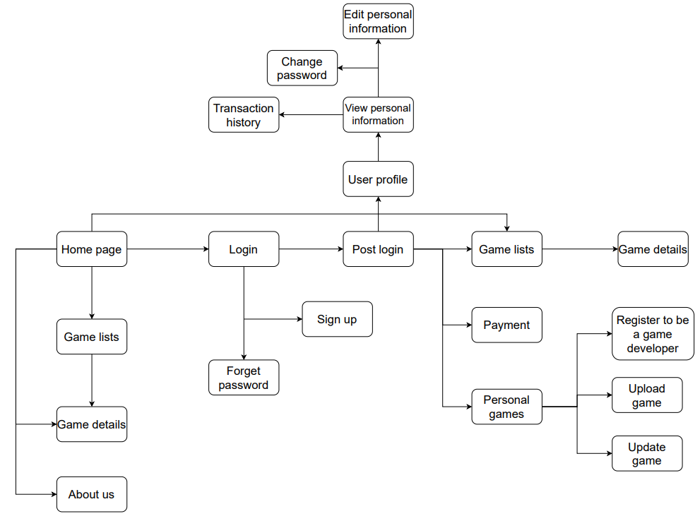

Figure 2.1: User screen flow

Admin Screen Flow:

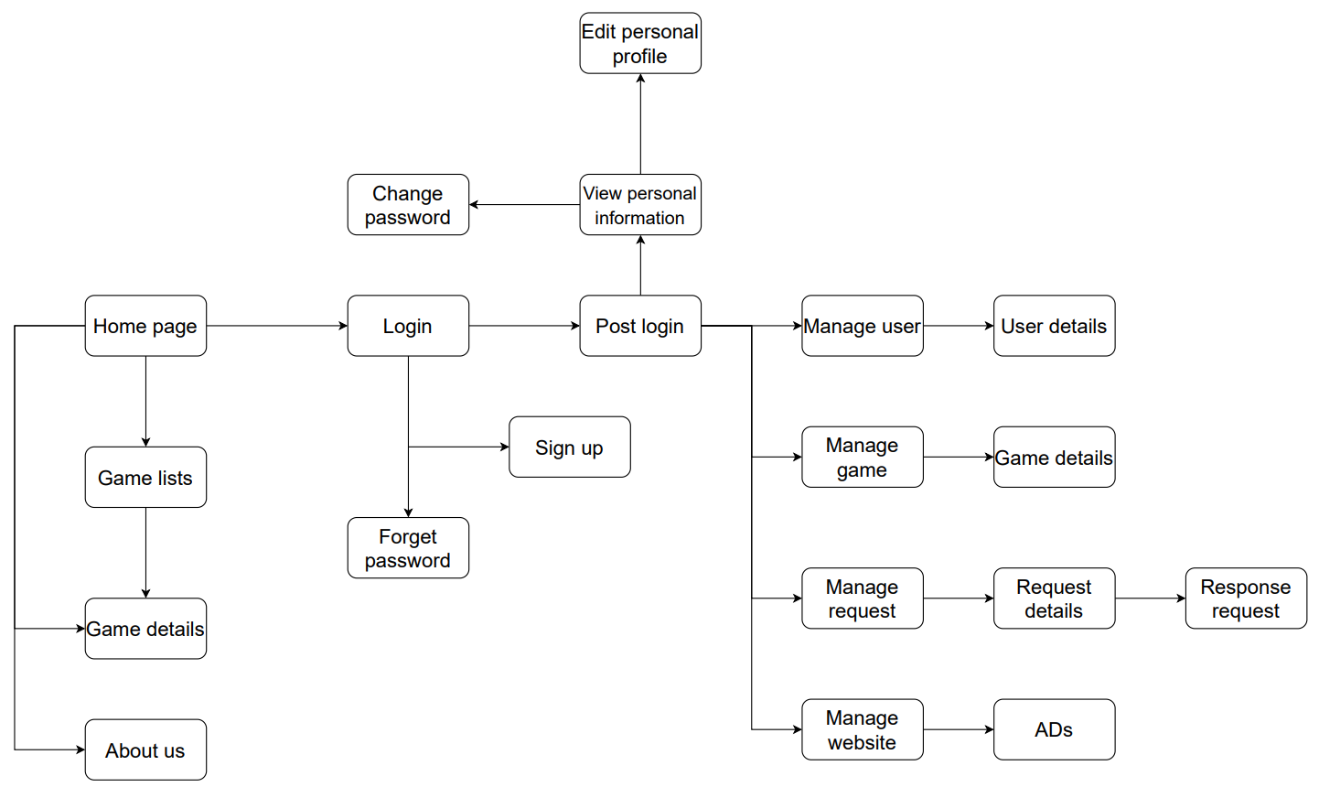

Figure 2.2: Admin screen flow

#### b. Screen Details

|  |  |  |  |
| --- | --- | --- | --- |
| **#** | **Screen/Function** | **Feature** | **Description** |
| 1 | Login | Common | Allow user to enter username and password to login. On this page, there are also options for user to register for new accounts or reset password in case he/she forgets it. |
| 2 | Sign up | Common | Allow user to register to the system by inputting required information. Then the system validates users and creates new user account using the inputted information |
| 3 | Forget password | Common | User will input email of the account then the system will send them an email of the new password of the account. After that, user must login and change the password. |
| 4 | Home page | Public | * Show contact information with social links of our group. * Show brief information of the team. * Show hot and recommended games. User can search for the game they want |
| 5 | Game lists | Public | After user search game, or click a category, the website redirect user to this page. User can see the list of games according to what user want to see. |
| 6 | Game details | Public | Show game details (including name, publisher, price, image, description, …) and some recommended games with the same categories. |
| 7 | About us | Public | Show information of the team. |
| 8 | User profile | User | Show user profile. There are also options for user to edit their information, change password and view transaction history. |
| 9 | Transaction history | User | Show user transaction history. Each transaction includes the amount of money, date, … |
| 10 | Change password | User | Allows user to change their account’s password. User must input old password and then their new password and confirm it. |
| 11 | Edit personal information | User | Allows user to change their information. User will input new information and submit. Then the system will change it for them. |
| 12 | Payment | User | Allow user to add money to the account. User must choose payment method and input the money they want to add. There is also a option to withdraw money and a request to refund money to the admin. |
| 13 | Personal games | User | User can view their game lists including bought-game list and self-upload game list. |
| 14 | Register to be a game developer | User | User can request admin to make him/her become a game developer. |
| 15 | Upload game | User | User can upload their own game. They will show their games and input the game’s information. But the game will be uploaded if it is approved by the admin. |
| 16 | Update game | User | User can update their uploaded games information (price, description, …) or update a new version of the game. |
| 17 | Manage user | Admin | * Admin can search for users by input name in the box on the top of the page. * Admin can view the lists of top ten users sort by having the most income, most active, … |
| 18 | User details | Admin | Admin can see their information, their account balance, their activities, their uploaded and downloaded games. |
| 19 | Manage game | Admin | * Admin can search for games by input name in the box on the top of the page. * Admin can view the lists of top ten games sort by having the most income, most downloaded, newest, … |
| 20 | Game details | Admin | * Admin can view game detail information * View the game’s income, downloads, rate, comments, … * Admin can also delete the game if the game violated the rule. |
| 21 | Manage request | Admin | Admin can view list of the requests. |
| 22 | Request details | Admin | Admin can view request details. They can delete it, accept it and response it. |
| 23 | Response request | Admin | Admin can fill a form and the form will be sent to the requested email. |
| 24 | Manage website | Admin | Admin can view the income of the web, the details of the income. |
| 25 | Ads | Admin | Update soon |

#### c. User Authorization

|  |  |  |  |  |
| --- | --- | --- | --- | --- |
| **Screen** | **Guest** | **Customer** | **Developer** | **Admin** |
| Login |  | X | X | X |
| Sign up | X |  |  |  |
| Forget password |  | X | X | X |
| Home page | X | X | X | X |
| * Search games | X | X | X | X |
| * View recommended games | X | X | X | X |
| Game lists | X | X | X | X |
| Game details | X | X | X | X |
| * Buy game |  | X | X |  |
| * Leave comment |  | X | X |  |
| * Rate |  | X | X |  |
| * Report |  | X | X |  |
| * View game information | X | X | X | X |
| About us | X | X | X | X |
| User profile |  | X | X |  |
| Transaction history |  | X | X |  |
| Edit profile |  | X | X | X |
| Change password |  | X | X | X |
| Payment |  | X | X |  |
| * Loading money to the account |  | X | X |  |
| * Request refunding |  | X | X |  |
| Personal games |  | X | X |  |
| * View games income |  |  | X |  |
| * Edit game’s information |  |  | X |  |
| Register to become a game developer |  | X |  |  |
| Upload game |  |  | X |  |
| Update game |  |  | X |  |
| Manage user |  |  |  | X |
| * Search user |  |  |  | X |
| * View sorted user list |  |  |  | X |
| User details |  |  |  | X |
| * View user information |  |  |  | X |
| * Send message to user |  |  |  | X |
| * View user’s game list |  |  |  | X |
| Manage game |  |  |  | X |
| * Search game |  |  |  | X |
| * View sorted game list |  |  |  | X |
| Game details |  |  |  | X |
| * View game information |  |  |  | X |
| * View game’s income |  |  |  | X |
| * Delete game |  |  |  | X |
| Manage request |  |  |  | X |
| * View sorted request list |  |  |  | X |
| Request details |  |  |  | X |
| * View request details |  |  |  | X |
| * Delete request |  |  |  | X |
| Response request |  |  |  | X |
| Manage website |  |  |  | X |
| * View website income |  |  |  | X |
| Ads |  |  |  | X |

In which:

* Guest: unregistered users.
* User: registered users who can purchase items online and interact with them(rate, comment,…)
* Publisher: registered users who sell their games to the customers.
* Admin: the system administrator.

#### d. Non-Screen Functions

|  |  |  |  |
| --- | --- | --- | --- |
| **#** | **Feature** | **System Function** | **Description** |
| 1 | User authorization | Authorization | Implementation of authorization mechanism in the system, including the specify the role of the logged-in user, his/her authorized page links displayed items menu and preventing unauthorized access via entering the links directly |
| 2 | Easy to use | Provide smooth flow, friendly UI | User don’t have to think about how this function works. We can achieve this by building comprehensive flow and designing user-friendly UI. |

## 3. Entity Relationship Diagram

## 

Figure 3.1: Entity–relationship model diagram

**Entities Description**

|  |  |  |
| --- | --- | --- |
| **#** | **Entity** | **Description** |
| 1 | User | The person that uses the website (buy games, upload their own games, …) |
| 2 | Admin | The person who acts as the system administrator. |
| 3 | Account | Including username and password, used to login. Only user with an account can buy, rate, … games and have other interactions. |
| 4 | Game | Is the main reason for people to visit the website and for the existence of this website 😉 |
| 5 | GameCategory | Each game has some categories. For example, The Walking Dead is tagged as Horror, Action, Adventure. |
| 6 | Request | Request from user to admin. They can be Game-upload request, Game-update request, … |
| 7 | Notification | Is the way the website notify user. |
| 8 | Payment | Consist of all things related to user’s money $_$ |

# II. Functional Requirements

1. Common feature
2. User login

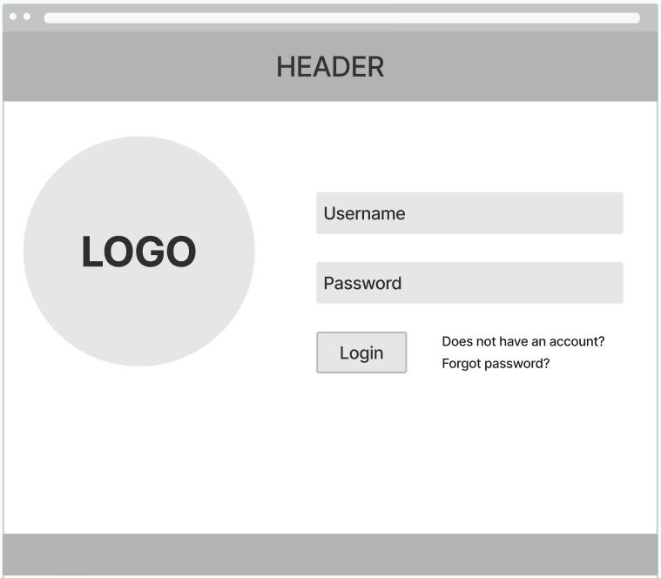

* Function trigger: this function will be triggered by a button on the home page
* Function description:

+ All roles from the system have access to this function.

+ The purpose of this function is to help the system authenticate users.

* Function detail:

+ Entering an invalid username or password the user will not be able to access the system

+ Entering a valid username and password the user will be able to access the system

+ In case user forgot password, the user can click the hyperlink “Forgot password?” and forward to the forgot password’s screen.

+ In case user don’t have an account, the user can click the hyperlink “Does not have an account?” and forward to the Register’s screen to create a new account.

1. Register account

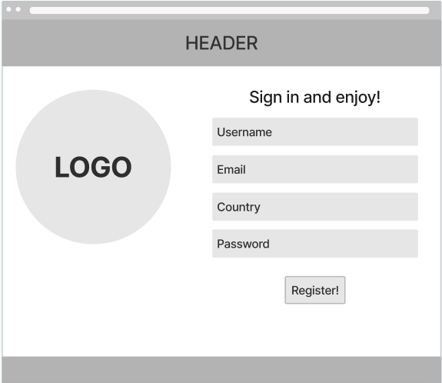

* Function trigger: this function will be triggered by a button on the home page
* Function description:

+ Guest role from the system have access to this function.

+ The purpose of this function is to create a new account.

* Function detail: This function will deal with the below scenarios:

+ Pressing the “Register!” button after entering all of the fields correctly will create a new account with the corresponding information in the database.

+ Should user enter an existed username, the system will pop up a notification and let user try again

1. Forgot password

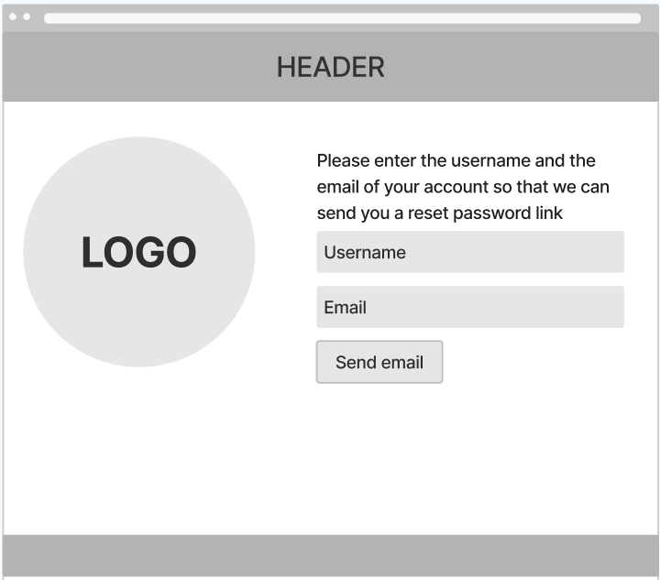

* Function trigger: this function will be triggered by a button on the login page
* Function description:

+ All roles from the system except for Guest have access to this function.

+ The purpose of this function is to reset user account’s password.

* Function detail: This function will deal with the below scenarios:

+ Pressing the “Send email” button after entering username and email of the account will send user an email of the new password, and the password of the account in the database will be changed.

+ Should user enter an invalid username or the wrong email, the system will pop up a notification and let user try again.

1. Public feature
2. Home page

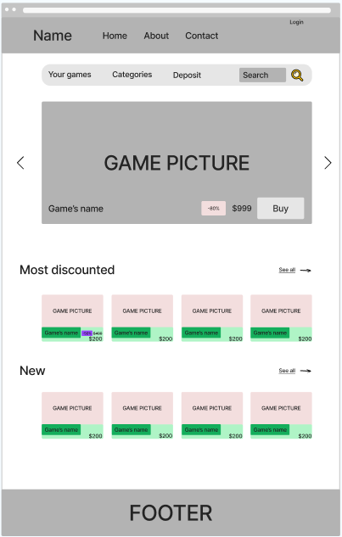

* Function trigger: the page will show up when user accesses the web application.
* Function description:

+ All roles from the system have access to this function.

+ The purpose of this function is to link other functions of the web application.

+ Show user some games that are hot or discounted.

* Function detail:

+ Have components to link to detail pages like game details, login, Game lists, …

+ Search games by name.

1. Game lists

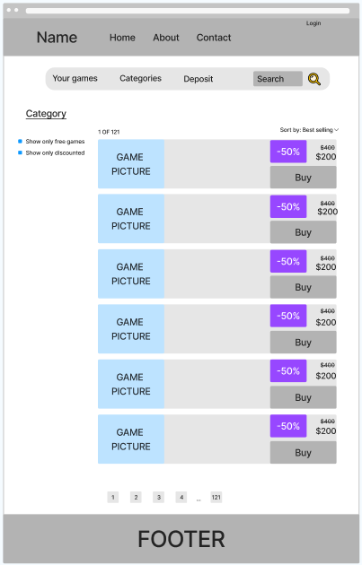

* Function trigger: the page will show up when user choose a category or search a game by name.
* Function description:

+ All roles from the system have access to this function.

+ The purpose of this function is to show all games that match with the user’s wish.

+ Search games by name.

* Function detail:

+ Sort game list (by price/discount/best-selling)

+ Filter games

+ Search games by name

+ Show some game information: photo, discount, price, name.

1. Game details

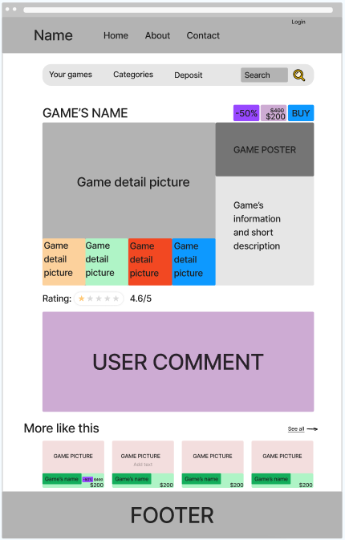

* Function trigger: the page will show up when user click a game.
* Function description:

+ All roles from the system have access to this function.

+ The purpose of this function is to show game’s detail information.

+ User can also read other users’ comment about the game.

+ Show some games that are something like this game.

* Function detail:

+ Show related games.

+ Show game’s detail information.

+ Allow registered users to buy the game if their account balance is enough.

1. About us

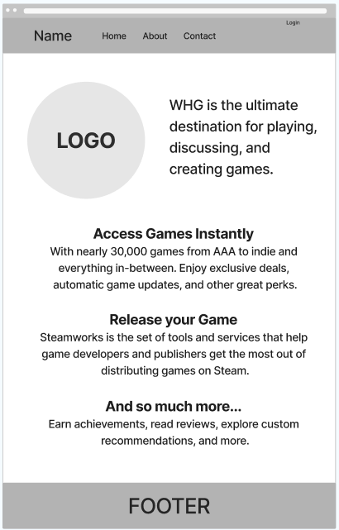

* Function trigger: the page will show up when user click “About” on the header of some pages.
* Function description:

+ All roles from the system have access to this function.

+ The purpose of this function is to show operator’s messages to users.

* Function detail:

+ Show operator’s wish and convenience that user may find in the web application

1. Admin feature
2. Main dashboard
3. Game lists
4. Game details
5. User lists
6. User details
7. Request lists
8. Request details
9. Response request
10. Website manager
11. User feature
12. User profile

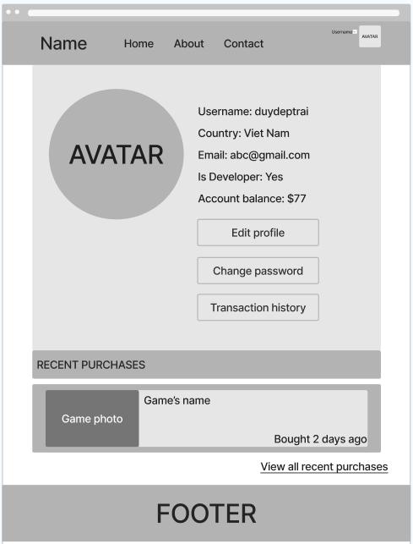

* Function trigger: the page will show up when user click his/her avatar on the header of some pages.
* Function description:

+ Only registered users have access to this function.

+ The purpose of this function is to show users their own detail information and the most recent purchase.

* Function detail:

+ Show detail information of the user’s account.

+ Link to some other functions: Edit profile, Change password, View transaction history and view all recent purchases.

1. Edit profile

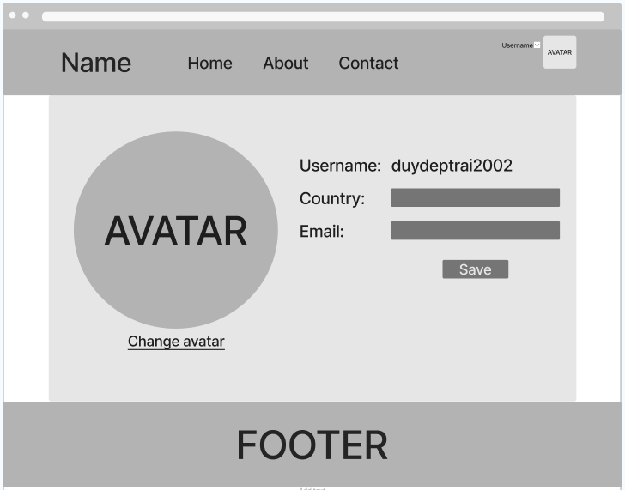

* Function trigger: the page will show up when user click “Edit profile” in the page User profile.
* Function description:

+ Only registered users have access to this function.

+ The purpose of this function is for users to change their account’s profile.

* Function detail:

+ Enable user to change their account’s avatar, country and email. If user don’t want to update Email for instance, he/she doesn’t have to fill that property. After clicking the button “Save”, user’s profile will be changed according to what user entered.

1. Change password

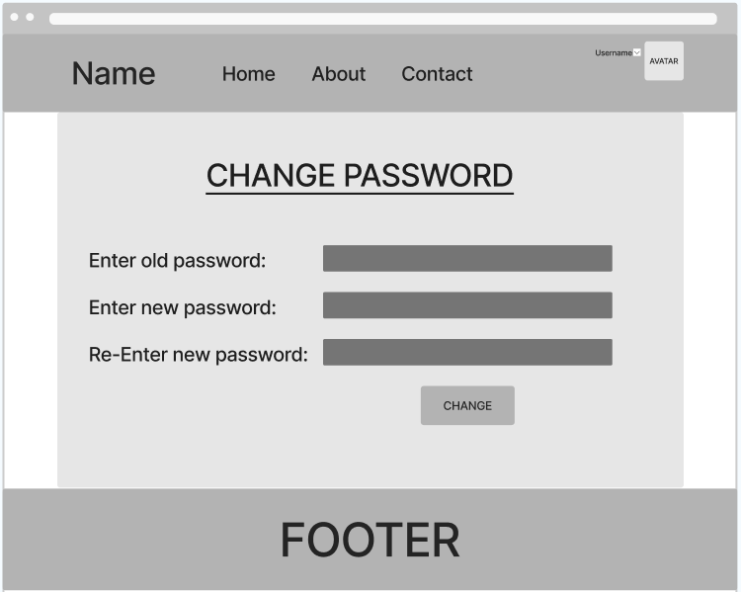

* Function trigger: the page will show up when user click “Change password” in the page User profile.
* Function description:

+ Only registered users have access to this function.

+ The purpose of this function is for users to change their password.

* Function detail:

+ Should users enter correctly, they can click button “Change” and the account’s password will be changed.

+ Should users enter incorrectly(null or different new password), the system will pop up notification and let user try again.

1. Transaction history

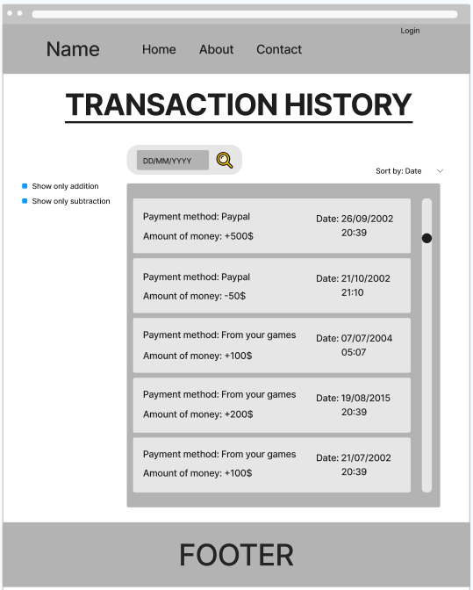

* Function trigger: the page will show up when user click “Transaction history” in the page User profile.
* Function description:

+ Only registered users have access to this function.

+ The purpose of this function is to show user their account’s transaction history.

* Function detail:

+ User can sort the history by money or by date.

+ User can filter the history by addition or subtraction.

+ User can view the payment method, the money and the date when the transaction was executed.

1. Payment

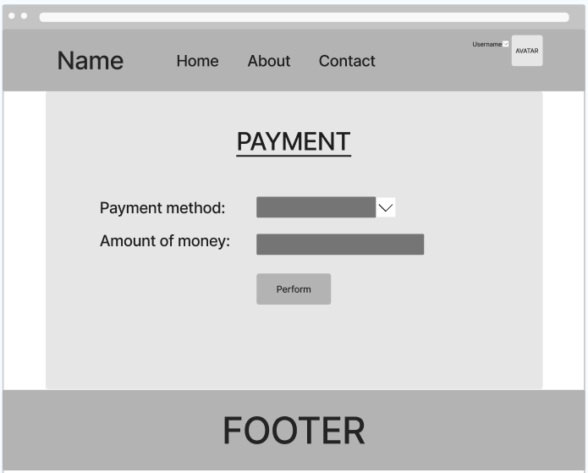

* Function trigger: the page will show up when user click “Deposit” in the home page.
* Function description:

+ Only registered users have access to this function.

+ The purpose of this function is for users to add money to their account.

* Function detail:

+ Allow user to choose payment method.

+ Should user fill correctly all the fields, the system will add money to user’s account.

+ Should user fill incorrectly, the system will pop up warnings and let user try again.

1. Personal games

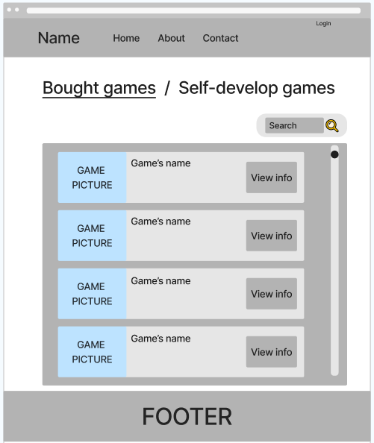

* Function trigger: the page will show up when user click “Your games” in the home page.
* Function description:

+ Only registered users have access to this function.

+ The purpose of this function is to show all games that they bought or uploaded.

* Function detail:

+ Show user their games (bought games and uploaded games).

+ Link to game’s detail information. User can see some more information(game’s income, …) if the game is uploaded by he/she.

1. Register to become a game developer

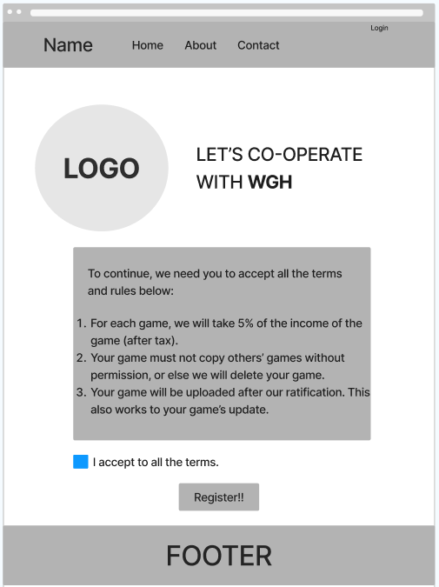

* Function trigger: the page will show up when user click “Register to become a game developer” in the page Personal games (in the case user already registered, the button disappear).
* Function description:

+ Only registered users have access to this function.

+ The purpose of this function is to “level up” users’ account. If registering successfully, they can upload their own games.

* Function detail:

+ Show user all the terms and rules they must comply to if they want to upload their own games.

+ Should user not click “I accept to all the terms.”, they will not be able to register.

1. Upload games

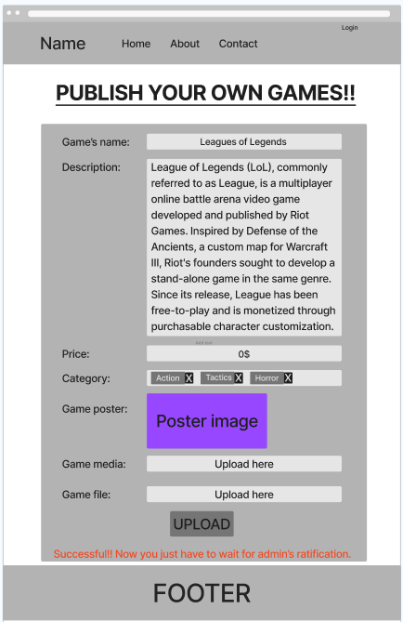

* Function trigger: the page will show up when user click “Upload” in the page Personal games.
* Function description:

+ Only registered users have access to this function.

+ The purpose of this function is for users to upload their own games.

* Function detail:

+ Should user fill up all the fields correctly, he/she can click the button “UPLOAD” to submit the game.

+ Should user enter incorrectly, the system will pop up warnings and let user try again.

1. Update games

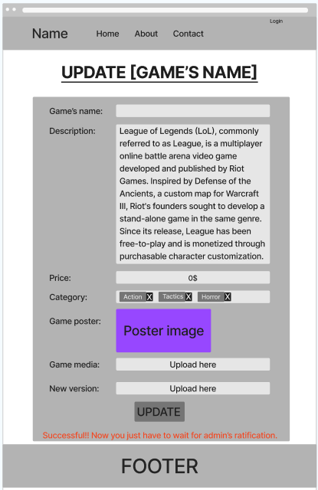

* Function trigger: the page will show up when user click “Update” in the Personal games page.
* Function description:

+ Only registered users have access to this function.

+ The purpose of this function is for user to update game’s information or release a new version of the game.

* Function detail:

+ Should user fill up all the fields correctly, he/she can click the button “UPDATE” to submit the game.

+ Should user enter incorrectly, the system will pop up warnings and let user try again.